

Accounting

Course Summary

Marc Delingat

delingat@yahoo.com
http://www.geocities.com/delingat

Table of Contents
Table of Contents 2
Course Summary 3
Module 1: An Introduction to Accounting and the Accounting Equation 3
Module 2: The Profit and Loss Account 4
Task One: Determining the consumption of the means of production 5
Task Two: Determining the Value of the Closing Work in Progress and Inventories 6
Module 3: The Balance Sheet 8
Module 4: The Cash Flow Statement 9
Module 5: The Framework for Financial Reporting 10
Accounting Concepts 11
Audit Methodology 12
Module 6: Interpretation of Financial Statements 12
Module 7: Emerging Issues and Managerial Options in Financial Reporting 16
Module 8: An Introduction to Cost and Management Accounting 18
Module 9: Cost Characteristics and Behavior 19
Break-even Analysis 21
Module 10: Allocating Costs to Jobs and Processes 23
Cost Statements (Where do costs come from?) 23
Plantwide vs. Departmental Rates 24
Joint Products and By-Products 24
Process Costing and the Equivalent Unit 25
Activity-Based Costing 25
Module 11: Cost for Decision Making 26
Absorption and Variable Cost Accounting 26
Cost Information for Management Decision 27
Module 12: Budgeting 28
Module 13: Standard Costing 30
Module 14: Accounting for Divisions 32
Divisions 32
Transfer Pricing 33
Module 15: Investment Decisions 34
Module 16: New Developments in Management Accounting 38
Target Costing 38
Life Cycle Costing 38
Throughput Accounting 39
Costing for Competitive Advantage 39
Thanks and Revision History 40

Course Summary

Module 1: An Introduction to Accounting and the Accounting Equation

Accounting may be defined as a series of processes and techniques used to identify, measure and communicate economic information which users find helpful in making decisions.

What is accounting?
- Accounting is a service function, not an end to itself.
- Accounting deals with economic information and is usually expressed in money values.
- Economic activity must be identified, then measured.
- Accounting is a communication device (the information must be relevant to the purpose for which it is designed).

Who are the users of accounting information?
Internal users: Directors, Senior Executives, Managers, Employees (and trade unions)
External users: Shareholders, Analysts, Creditors, Tax Authorities, the public

Accounting Equation
Assets = Owner’s Equity + Liabilities

The balance sheet is a collection of balances after each transaction has been completed and recorded. Accounting entries involve a mixture of cash-driven items and judgment-driven items. Items for expenditure accounted for via the balance sheet are called capital expenditure.

Fixed assets are of relatively long life and are generally used in the production of goods and services rather than be held for resale.
Current assets are assets that are either currently in the form of cash or are close to being converted into cash within a short period of time (usually a year).
Current liabilities are those obligations that a company must meet in cash within a short period of time (usually a year).

A profit and loss account shows how a company’s profit was made. Profit is the excess in sales revenue over cost incurred in generating the revenue. Items of expenditure accounted for via the profit and loss account are called revenue expenditure.

A cash flow statement portrays only those economic events of a business that affect the cash flow. Why is the cash flow statement so important? It breaks the conventions separating the balance sheet and the P&L account and states all events that affect the cash flow.

Acronym | Meaning
OE | Owner’s Equity
LTL | Long Term Loan
P&E | Plant & Equipment
F&W | Factory and Warehouse
RMI | Raw Material Inventory
FGI | Finished Goods Inventory
MV | Motor Vehicles

Sole Trader
- Can start trading at any time with the assets at his disposal
- Has to distinguish between transactions that are domestic and those that pertain to his business
- Has unlimited liability
- No requirement to make public the P&L account and the balance sheet each year
- Will have to make an annual tax return and will be taxed on the profit

Partnership
- Group of individuals contribute various assets
- Is usually governed by a partnership agreement that among others specifies the method for sharing the annual profit.
- The partners have unlimited liability
- No requirement to make public the P&L account and the balance sheet each year

Corporation
- Limits the liability of the owners (called shareholders) to the amount of equity (share capital) paid into the company
- Must make public it’s annual accounts which must be audited by a registered auditor
- The share capital is split into small units (e.g. $1), the face value of the share, called the par value, or nominal value. The market might value a share higher than the nominal value, however, that does not influence the accounting equation, as the company still has access to the original paid in capital.

Financial accounting or financial reporting depicts the total picture for a firm in the accounting period (e.g. total sales, total costs, total profits, and total asset structure). The information is compiled after the accounting period is over and the books of account have been closed. It derives from the legal obligation of the management to report to the owners how they have used the resources during the accounting period.

Management accounting provides information, such as actual and projected costs and prices of individual products, projected sources and uses of cash, projected and actual costs of departments and processes, etc. in order to enable management to analyze past and predict future events and act appropriately.

Module 2: The Profit and Loss Account

The profit is the result of the transformation processes a company is engaged in a given time period and can be viewed as the difference between
- a measure of accomplishment (what has been achieved in sales) and
- a measure of effort (what these sales have cost).
Accomplishment is generally measured at the first point in the operating cycle for which the following conditions are met:
  - The principal revenue producing service has been performed, i.e. the product has been made and delivered against a firm order.
  - All costs that are necessary to create the revenue have been either incurred, or, if not yet incurred, are either negligible or can be predicted within an acceptable degree of accuracy.
  - The amount ultimately collectable in cash can be estimated within an acceptable range of error.
When is accomplishment achieved?
- Enquiry: too early, order may not emerge
- Order: too early, cost too uncertain, customer may walk away before delivery
- Inventory of finished goods: too early, unsold goods may never sell. Also the ultimate sales price may be unknown
- Ship
- Invoice: about right, goods are normally invoiced at the time of shipment
- Cash received: unnecessarily late, unless there is evidence that customers will not pay for goods

Accounting conventions underlying the measurement of sales accomplishment:
Realization Convention: Only products that have been sold are measured as sales. Products that are completed or partially completed and have not realized value for the business are not included.
Accruals Convention: Cash does not have to be received to create value; an obligation from a creditworthy customer is good enough to be called a sale. The accruals convention also covers the situation where an entity pays an invoice for a product or service which covers a certain time period that stretches beyond the date of the reporting statement.

Accounting conventions underlying the measurement of effort:
Matching Convention: Profit is arrived at by matching the effort (or cost) with the units shipped and invoiced to the customers (sales) during the period. Efforts are al cost involved in producing saleable products and the costs involved in actually selling the products which are recognized in the measurement of sales accomplishment.
Allocation Convention: the first task is to determine how much of each means of production in money terms was consumed during the accounting period (cost determination). Not all means of production are consumed during the accounting period. The second task is to determine how much of each means of production should be matched with sales revenue and how much much should be added to the inventory of unfinished and finished goods.
Cost Convention: The cost used for different means of production is the historical price (also called acquisition price) paid for them when they were acquired.

Task One: Determining the consumption of the means of production
- Use of raw materials: determined by deducting the physical quantity of raw materials at the end of the year (or accounting period) from the sum of opening inventory and purchases during the year (or accounting period).
- Labor: the payroll for the time period is the usual source of he measurement of labor effort used and is in money terms
- Depreciation of fixed assets: the consumption (or decline in value) of the fixed assets used in the production has to be considered as a cost. Three factors have to be taken into account to define every depreciation model used:
  - Actual historic (acquisition) cost, including installation charges
  - Estimated net residual amount that can be obtained when the asset is disposed of
  - Estimated useful life of asset to current owner

Depreciation Methods
Straight Line Depreciation 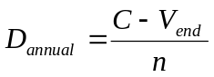 Simple and reasonable methods for many assets
Reducing Balance Depreciation 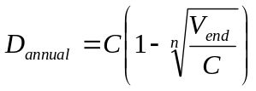 Assumes that a fixed asset is more efficient in generating revenue in the early years of it’s life. Repair also tends to be lower in the earlier year in the live of an asset so early high depreciation counterbalances high later repair cost.
Consumption Method 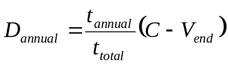Assumes that the greater the number of running hours of the asset the greater the wear and tear on the machine.

D_{annual}: annual depreciation amount
C: acquisition cost
V_{end}: scrap value (or estimated value when asset is sold)
t_{annual}: annual running hours
t_{total}: total running hours

Task Two: Determining the Value of the Closing Work in Progress and Inventories
The closing inventories of work in progress and finished goods have to be deducted from the total cost measured in Task One: the balance is set off as a charge in the profit and loss account.

Types of inventory in a manufacturing company:
- Finished goods inventory
- Work-in-progress inventory
- Raw materials and supplies inventory

Inventory Valuation Methods: Inventory, once physically counted, is valued using a mixture of the cost and conservatism convention; inventory is valued at the lower of cost or net realizable value.
- FIFO: It is favored by many businesses because it is consistent with the physical flow of goods and the balance sheet inventory is carried at realistic values (provided the stock turns over quickly). Problem is that reported income during periods of rising prices is relatively high as lower cost of sales in the past have been offset against sales revenue.
- LIFO: Using this valuation method lower profit is reported in times of rising prices and replacement of inventories is therefore made easier. However many managers do not like the resulting lower profit figure.
- Average Method: The weighted average unit cost of the goods available for sale is applied to the units sold to calculate the cost of goods sold and the ending inventory of goods.

Product cost (such as raw material and labor) can be traced directly to the products being manufactured or to the production process. Product costs can include indirect costs (managers, supervisors, warehouse staff, heat, light, etc.) from expenses not directly involved in the manufacturing process, but whose services are connected to the manufacturing process.
Period costs are incurred so that a company’s products can be sold, and the money collected from the customer, but they typically do not add value to the products unsold at the end of the accounting period. Period costs are fully set off against revenue in the P&L account, none are associated with inventory.
The exact distinction whether an expense is a product or a period cost is not universally agreed upon.
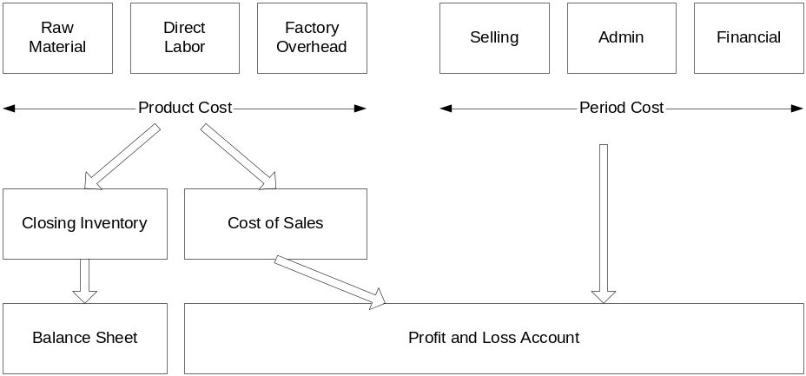

Types of Profit
Gross profit (sales – cost of sales) is a good measure of the transformation (manufacturing) process.
Net profit (gross profit minus period costs) is a good measure of managerial efficiency against previous periods as well as other companies in the same space
Net profit before interest charges and taxes: is a good measure of management’s efficiency of manufacturing, selling and distributing unaffected by the financial arrangements.
Net profit after interest charges but before taxes and interest payments (to non-shareholders) are good measures of the company’s financial structure.
Impact of changing value of money
- Depreciation: due to inflation the replacement cost will not be the historic cost so a company could choose to use replacement cost instead of the historic cost to calculate the annual depreciation amount. The “top-up” depreciation is the amount added to the depreciation charge each year to bring the depreciation calculation in line with the current replacement cost for the fixed asset.
- Cost of Sales: the cost of sales adjustment removes the holding gains (profit from holding inventory while it rises in value) from reported profit. One way to calculate the cost of sales adjustment is the averaging method. The current cost of sales can be computed by revising the reported cost of opening and closing inventory to the average current cost for the year, and the cost of sales adjustment will be the difference between the current cost of inventory at the date of the sale and the the amount charged in computing the historical cost.

Module 3: The Balance Sheet
Asset Classification:
- Untransformed means of production: land, buildings, plant, machinery, and raw materials
- Transformed means of production: work-in-progress and finished goods that have not yet been released to the P&L account. If they are released, these costs turn into expenses as no further benefit is anticipated from these costs.

Fixed assets are assets that the company keeps for a substantial period of time and that are not intended for resale but used in the course of business. It is the intention of management as to the use of the asset that determines whether an asset is a fixed asset.
Categories of fixed assets:
- Land, usually not depreciated since it has an infinite life and thus does not normally decrease in value. Accountants record the acquisition cost together with the legal fees and the cost of preparing the land. This action is called capitalizing the fees and preparation expenditures compared with writing them off against profit in the period of incurrence. As the value of land changes accountants might not apply the cost convention anymore but rather reevaluate the value of the asset and add/subtract the difference from the shareholder’s equity. The P&L of a company is not affected by this reevaluation.
- Buildings are sometimes shown together with land. Other companies depreciate buildings over time as they have a limited lifespan.
- Plant and Equipment
- Fixed Assets not owned by the company: Assets leased under the terms of a finance lease (one where ownership will revert to the lessee at the end of the lease) on the balance sheet; the asset is listed under “fixed assets” and the future payments under “creditors”
Current Assets are assets which are expected to be sold or consumed during the normal operating cycle of the company (usually one year). Categories of current assets are:
- Inventories: the valuation is based n the ‘lower of the cost or current market value’ rule; cost is defined as direct manufacturing cost plus a share of manufacturing overhead (period cost such as administration overhead are not included in inventory); inventory valuation methods can influence the value of the inventory and any changes in valuation methods has to be properly disclosed
- Debtors: payment by debtors is expected shortly after the start of the next accounting period. Provisions for bad debts are entered at the beginning in the P&L account and subsequently changes in those provisions and actual bad debts are entered in the P&L account.
- Cash
Current Liabilities are liabilities which is plans to meet in the short term by the payment of cash. Examples are: creditors, bank overdraft, taxes payable, dividends payable, accruals, deferred revenue.
Net Assets
Net Current Assets (Net Current Liabilities) = Current Assets – Current Liabilities
Net Assets of the Enterprise = Net Current Assets + Fixed Assets

Ownership Equity are internally generated assets are the original equity introduced by the owner(s) and the retained profit generated through operation.
Long term loans are generally the most important external source of funds. Lenders (unlike shareholders) have an enforceable right for annual fixed interest payments.

Gearing = Long term debt / total assets

In years of healthy profits shareholders will receive better return on their money in a high geared company, but when profits dip the heavy burden of debt

Module 4: The Cash Flow Statement

Users of financial statements, including Managers, need a reconciliation between profits and cash; this reconciliation is provided by the cash flow statement. They are used to “unstitch” the accounting principles applied to compile balance sheet and income statement. The cash flow statement reveals whether the entity has sufficient cash to finance future operations and ambitions to pay dividends and interest to investors, lenders, and owners of the company.

What is cash?
- Cash balances
- Bank balances
- Cash equivalents (Temporary investments of cash not required at the moment by the business. These investments are readily convertible into cash, or, if left alone would mature within 3 month.)

Source of cash:
- Profit from operations (Profit after depreciation plus depreciation added back in results in cash from operations)
- Capital introduction (by owners)
- Increase in creditors
- Sales of fixed assets
- Loans
- Decrease in inventories
- Decrease in debtors
Where does cash go?
- Loss from operations (If loss after depreciation plus depreciation added back in still results in a negative number this is the cash consumed by operations)
- Capital repayments
- Decrease in creditors
- Purchase of fixed assets
- Repayment of loans
- Increase in inventories
- Increase in debtors

The major categories of cash from (according to Financial Reporting Standard)
- Cash flow from operating activities
- Cash flow from return on investments and servicing of finance
- Taxation
- Capital investment
- Acquisitions and disposals
- Equity dividends paid to shareholders
- Management of liquid assets
- Financing

What is needed to draw up the cash flow statement?
- The profit and loss account for the period
- The balance sheet at the start of the period
- The balance sheet at the end of the period
- Supplementary notes to the financial statements

Module 5: The Framework for Financial Reporting

Disclosure
Sole traders and partnerships are liable at law for the full extend of any debts that they might incur. Therefore there is no obligation by law for those entities to disclose a statement of their financial affairs on a periodic basis.
At companies are the liability extends solely to the extend of the shareholdings in the company. Therefore companies regularly have to disclose statements on their financial affairs regularly (normally once a year) in order to help creditors assess the creditworthiness.
For large companies with many shareholders the law requires the publishing of financial information in order to protect the shareholders in a similar way than the creditors.

Sources of Disclosure Requirements:
- Government legislation (e.g. in the form of the Companies Acts 1985 and 1989 for GB)
- The accounting profession’s rules of procedure contained in Accounting Standards and International Accounting Standards
- The requirements of the Stock Exchange Listing Agreement for companies whose ordinary shares are listed on the Stock Exchange

Limitation to Managements ability to select the accounting policies:
- True and fair view: Management has to choose policies so that the financial statements produced reflect a true and fair view of the state of affairs of their company
- External auditors: The external auditors must approve the selection of the accounting policies
- Consistency: Once chosen, management must consistently apply the policies from year to year unless material conditions have changed significantly. In such an event the change in accounting policies must be disclosed.

Called-up share capital: Companies are usually authorized to raise a certain sum of money through selling of ordinary shares. This amount is normally fixed at a sum far greater than required for ongoing operations, thus enabling the company to finance an expansion should that be deemed appropriate. When the amount issues reaches the authorized limit, the company will petition the courts to raise the limits on authorized share capital.

Share premium account: The difference between the face value of a share and the price at which it was sold in the market is recorded by the company in the share premium account.

Comments on financial statements:
- Disclosure requirements are numerous and complex and require detailed interpretation by company management, accountants and lawyers, and by the auditors.
- A corporate tradition has been built up to disclose the absolute minimum information required. Very rarely does company publish information that is not required.
- Despite rigorous application of disclosure requirements, large gaps in information can still be detected by interested parties.

Accounting Concepts
Going Concern Concept: If there is no evidence to the contrary a company assumes that it will continue to do business for the foreseeable future. This assumption allows management to write down the assets of a company (depreciate the assets) in an orderly manner over time, predict continuous inventory disposal, sales, and payment of creditors. Any know, significant, likely occurrence which may jeopardize the company’s future must be reflected immediately in the accounts (which would usually lead to an accelerated write-down of assets).
Accruals Concept: A company does not necessarily need to wait for cash to change hands before accounting for revenue and costs. As an example, revenue can be recognized when the product has been shipped and invoiced and there is reasonable expectation to get paid.
Consistency Concept: Unless there are pressing reasons to change accounting techniques and methods (such changes being disclosed) it is assumed that the treatment of like items between one year and another is the same.
Prudence Concept: Revenues and Profits are not recognized until virtually all efforts have been expended and the customer is likely to pay; all costs and losses, actual and expected, are recognized immediately.
Non-Aggregation Concept: In determining the aggregate amount of any item the amount of each individual asset or liability that falls to be taken into account shall be determined separately. For example, a company might be tempted to disclose a figure for net current assets only; the non-aggregation concept requires separate disclosure of current assets and current liabilities.

Role of an external auditor: The auditor provides a report on the accounts examined by them to the shareholders. The report forms part of the published financial statements. The report shall state, whether, in the auditors opinion,
- the accounts give the information required by the legislation (e.g. the Companies Act 1985) in a manner required by the legislation,
- a true and fair view is given of the profit (loss) for the year,
- a true and fair view is given of the balance sheet at the year-end,
- in case of a holding company submitting group accounts they have been properly prepared as to give a true and fair view of the state of affairs of the profit and loss of the company and it’s subsidiaries so far as concerns the members of the company.
The auditors have to also state in their reports if:
- they have been unable to obtain all the information and explanations which they require
- proper books of account have not been kept
- proper returns adequate for the purpose of their audit have not been received from branches or subsidiaries not visited
- the accounts are not in agreement with the books

The auditors report is usually unqualified, meaning that they have no reason to deviate from the above opinion. If the report is qualified the qualification should state specifically and positively the reason why, and the extent to which the auditor is not satisfied. It should also state the effect on the accounts and, wherever possible, the amounts involved.

Audit Methodology
- Examination of the systems of bookkeeping, accounting, and internal control to ascertain whether it is appropriate for the business and properly records all transactions. Followed by such tests and enquiries necessary to ascertain whether the system is properly carried out.
- Comparison of the balance sheet and profit and loss account and other statements with the underlying records to see that they are in accordance therewith.
- Verification of the title, existence, and, value of the assets appearing in the balance sheet.
- Verification of the amount of the liabilities appearing in the balance sheet.
- Verification that the results in the profit and loss account are fairly stated.
- Confirmation that the statutory requirements have been complied with and that the relevant accounting standards have been applied correctly.

Internal control is a term used to describe all the various measures taken by the owners and managers of a company to direct and control their employees.

The level of materiality is the threshold that external auditors set themselves for transactions amounts under which they will not examine in depth.

Module 6: Interpretation of Financial Statements

Liquidity Ratios are designed to measure a company’s ability to meet maturing short term obligations.

Current Ratio = Current Assets/Current Liabilities

A company is in good financial position to meet it’s future obligations if current assets exceed current liabilities by a comfortable margin (rule of thumb: Current Ratio >2).

Quick Ratio = (Current Assets- Inventory)/Current Liabilities

The Quick Ratio (also called the “Acid test”) removes inventory, which is sometimes slow moving, from the calculation and thus provides a more rigorous test of the company’s ability to pay its maturing liabilities. If a company finds itself with a quick ratio inferior to the industrial average but its current ratio matches the average the management should re-consider the amount of inventory that the company carries.

Profitability Ratios strike at the heart of a companies activities, namely whether it controls expenses and earns a reasonable return on funds invested.
Gross Profit Margin = Gross Profit/Sales

A company must earn a significant gross profit margin to be able to bear the burden of other corporate overhead.

Profit Margin = Profit Before Interest and Taxes/Sales

As the tax charge in company accounts is often distorted by a variety of fiscal provisions and often reflects tax liabilities incurred in earlier accounting periods, the profit before taxes is sometimes a better indicator.

Return on Total Assets = Profit before Interest and Taxes/Total Assets

Sometimes the return on assets is calculated using only the productive assets (excluding goodwill (if any), and investments). If the return on assets is low, the company should look into shedding unproductive assets.

Return on Inventory = Profit Before Interest and Taxes/Inventory

Sometimes it is important to review the return on a specific asset, such as inventory to compare against other companies in the industry.

Return on Capital Employed = Before Interest and Taxes/Capital Employed

Capital Employed is usually defined as total assets minus the current liabilities. Alternatively the sum of the owner’s equity and the long term loans and provisions could be used. The Return on Capital employed shows the magnitude of the resources locked up in the business and working for the

Return on Owner’s Equity = Profit Attributable to Shareholders/Owners Equity

The share of the profit attributed to minority interests is deducted (not attributed to the shareholders). Normally an increase in the Return on Equity is a good sign, but it might also point to a problem with the company relying too heavily on debt.

Capital Structure Ratios examine the percentage of a company’s total assets which are contributed by shareholders and the effect and risk of such percentage on earnings.

Fixed to Current Asset Ratio = Fixed Assets/Current Assets

This ratio by itself does not provide a major insight into the company. It’s value lies in comparing it with the ratio of other companies.

Debt Ratio (Gearing) = Total Debt/Total Assets

Total debt can be defined as all non-equity financing without minority interests.

Debt to Equity Ratio = Total Debt/Total Equity

Shareholder perspective on gearing: A low-geared company protects its shareholders in times of economic hardship but by the same token fails to allow them to cash in on bumper rewards when the business turns up. When the business is good the growth has to pay dividends that are high to the shareholders. If the gearing was higher in high grow times the shareholders would receive a higher portion of the profits as the interest paid on the loans would still remain the same.

Times Earned Interest = (Profit Before Tax + Interest Charges)/Interest Charges

Measures the extent to which earnings can decline without the company finding itself unable to meet the annual interest costs.

Efficiency Ratios measure a company’s asset management.

Inventory Turnover = Sales/Inventory

Inventory is an asset that companies require to invest in to act as a buffer for raw materials and supplies as well as finished goods. The number has to be evaluated against a variety of different factors specific to an industry. In general if the inventory is low, lower costs of maintaining it as well as better return on assets will result.

Average Collection Period (day sales outstanding) = Debtors/Sales per day

The shorter the average collection period, the more stringent the credit management of the company regarding it’s customers. A short average collection period avoids companies having to borrow to finance ongoing operations due to outstanding payments from customers.

Fixed Asset Turnover = Sales/Fixed Assets

Again, as will all the other ratios the number is only meaningful when compared to other companies or past accounting periods. A low Fixed Asset Turnover shows that either a company is more efficient at using the assets it has to produce revenue, or that other companies are valuing their fixed assets higher (e.g. a more recent re-evaluation of the value of the land and buildings).

Dupont Chart

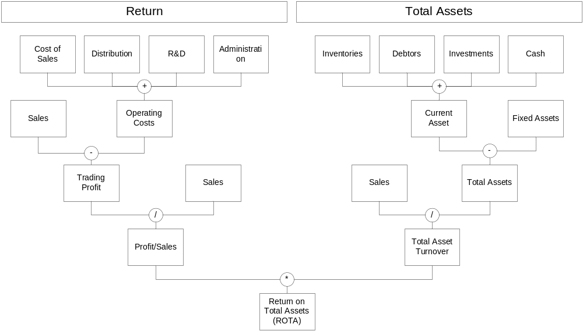

One Hundred Percent Statement
The On Hundred Percent Statement is a frequently used technique for profitability and cost control analysis. All items of cost are expressed as percentage of sales.

Basic Stock Market Ratios

Earnings per share (EPS) = Net Profit for the financial year/Number of ordinary shares in issue

Price/Earnings Ratio (PE Ratio) = Market Price/EPS

Dividend Yield = Dividend per share/Market Price per share

Dividend Cover = Net profit of the year/Dividend payout

The dividend ratio is designed to draw attention to overgenerous management decisions to pay out too much in dividends. A company does not need to earn profits to pay a dividend but if it does not, it will erode reserves and this action can not go on indefinitely.

Module 7: Emerging Issues and Managerial Options in Financial Reporting

Capitalization vs. write off for research and development (R&D) expenditures: Research costs should be written off as there is no guarantee how much of each years expenditure will bear fruit. Development cost may be capitalized given that:
- there is a clearly defined project;
- the related expenditure is separately identifiable;
- the outcome of the project has been assessed with reasonable certainty as to its technical feasibility and its ultimate commercial viability (considering factors such as market conditions and competition, public opinion, consumer and environmental legislation);
- the aggregate of the deferred and further development cost, related production, sales, and administrative cost is reasonable expected to be less than the total related sales (or other revenue)
- adequate resources are (or will be) available to complete the project and provide the resulting increase in working capital

Off-Balance-Sheet Transactions can be described as financing schemes deliberately designed to persuade the reader of a company’s accounts that the company’s financial structure is something other than it is.
- Quasi-Subsidiaries: A subsidiary must be consolidated into the group profit and loss account and balance sheet; its assets and debts are added to those of the holding company for disclosure purposes. An investing company can so engineer the share capital and voting rights of another company that it avoids owning more than 50% but retains control of managerial decisions. Financial regulation requires consolidation of quasi-subsidiaries as the control (that is ability to direct financial and operating activities in order to gain an economic benefit) is still with the parent company.
- Consignment Inventories: e.g. manufacturers sending dealers cars that are only paid for by the dealer when the car is actually sold. The manufacturer retains title of the vehicle. The dealer is able to not show a large part of it’s assets on the balance sheet. Financial regulation requires that if the unsold goods can be returned without a significant penalty, the dealer does not have to show the vehicles on his balance sheet.
- Sale and Re-purchase Agreements: Company may decide to sell a certain asset (e.g. aging whiskey at a distillery) to a bank with the goal of moving the asset off it’s balance sheet. At the same time the company enters a re-purchase agreement to but the asset back at a time in the future. Financial regulation is concerned with the “substance of the sale”. If the risks and rewards of owning the assets are not really transferred, the agreement should be accounted for as a financing deal.
- Debt Factoring: Companies sometimes sell outstanding debt to a finance house for debt collection at a value that is less than the face value of the debt. Problems arise, when, as part of the factoring deal, the finance house has recourse to the company when any of the debts prove to be irrecoverable. Financial regulation requires that in that case the originating company to keep a proportion of the “sold” debts on the balance sheet together with a matching liability to the finance house. Only when the debts have been recovered by the finance house should both items be taken off.

Accounting for Acquisitions and Mergers can be done using acquisition accounting or merger accounting (also called business combination or “pooling of interest” accounting method). Acquisition accounting is used when the holding company acquires more than 50% of the equity share capital of the subsidiary for cash, or shares in the holding company, or a combination of both. Sometimes a sizeable minority of original shareholders remains in the subsidiary.
Merger accounting presumes agreement between the two parties to pool their interests rather than for one to hand over the assets to another. The accounting statements of in merger accounting attempt to portray this harmonious coming together by restating both companies accounts as if the companies had always been one.
Under acquisition accounting the balance sheet of the holding company will have increases in goodwill and the share premium account. Goodwill should not be carried as an asset on the balance sheet beyond it’s useful life. Writing off goodwill systematically has a negative impact on profits; writing it off through the reserves of the company may reduce them dramatically as well. Merger accounting avoids the problem of goodwill. However merger accounting can only be adopted when the following conditions are met:
- None of the parties sees itself as acquirer or acquired
- None of the parties dominates the management of the combined entity
- The relative sizes of the entities are not so disparate that one company dominates the combined entity by virtue of its relative size
- Each of the parties in the combination receives primarily equity shares
- No equity shareholders of any of the combining entities retain any material interest in the future performance of only part of the combined entity

When a company takes over another company’s assets and liabilities there have to be recorded in the holding companies books at the fair value rather than the book value. Goodwill comprises “that extra something” that acquirers see hidden in the business activities of the acquirees which has value to them. Goodwill is an intangible asset – value locked up in one company which another company is prepared to pay for because it will yield future economic benefits. Goodwill can be accounted for in two ways:
- Writing off the purchased goodwill at the moment of the acquisition against group reserves
- Capitalize the amount paid as an asset and depreciate the asset over the lower of its useful economic life or 20 years

At all times management is required to subject goodwill to an impairment test, a detailed consideration of the inherent value underlying the number.

Brands can be accounted for as intangible assets on the balance sheet. There are (among many others) two ways by which to account for brands as intangible assets:
- Historic costs: Previously written off costs (such as marketing, advertising, R&D, etc.) are written back into the financial statements through the reserves. In effect the management is telling its shareholders that their stake in the company is now worth more than last year as the management now has the view that the cost incurred last year was expended to build up the brands.
- Earnings Method: under this method management must attempt to attribute the actual earnings of a company to specific brands and then apply a multiplier to this figure which reflects the brand’s strength over the foreseeable future. This method his highly subjective as it might be very hard to attribute sales and cost figures to specific brands. In addition the multiplier is entirely subjective.

An operating review gives the financial director scope to highlight difficulties that she had in abiding by a certain accounting standard and is meant to provide an opportunity to produce a clear, balanced, and analytical discussion of the company’s performance over the last year and a view of the future opportunities and difficulties that face the company. An operating review could include discussion on the following:
- Changes in market conditions
- New products and/or services introduced
- Changes in market share
- New activities, discontinued activities, and other acquisitions and disposals
- Scarcity of raw material and labor skills
- Environmental protection costs and potential environmental liabilities
- Training programs
- Financial contributions from the different business units
- Any subjective judgments to which the financial statements are particularly sensitive

A financial review could contain the following discussions:
- Capital structure of the business (maturity profile of debt, type of capital instruments used, currency and interest rates)
- Capital funding and treasury policies as well as sensitive items such as financial instruments for hedging purposes
- Cash generated from operations and other cash inflows during the period
- Restrictions on the ability to transfer funds within the group
- Debt covenants which could have the effect of restricting the use of credit facilities
- Strength and resources of the business whose value is not fully reflected on the balance sheet. An example could be any amount spent on R&D that has not yet been capitalized

Module 8: An Introduction to Cost and Management Accounting

 | Management Accounting | Financial Accounting
Structure | No formal structure, can be designed to suit many purposes, each with its own set of guidelines | Highly structured around the accounting equation
Rules | No externally imposed rules. Rigid handling of asset valuations, overhead allocation and revenue recognition is relaxed. | Hemmed in by general accounting principles to enable comparison across companies.
Compulsory | No, but few succeed without a system, however informal. No value in maintaining one if it is not useful. | Yes, companies are obliged by law to produce external accounts.
Money terms | Not exclusively | Yes, financial statements are drawn up exclusively in money terms
Time Spans | Information tends to be future oriented. Management might compromise precision for speed | Records and reports past events as accurately as the underlying accounting principles permit
Whole or parts | By its nature fragmented. Focuses on product lines, departments, processes, etc. Information can be reworked in many different ways | Reports the events of the company as a whole
Audit | Strictly speaking, no, although the external auditors may with to test the internal controls by examining aspects of the management accounting system. An internal audit function might use the management accounting system as it’s basis | Yes, accounts have to be audited by a registered auditor

Cost accounting is a major and essential part of management accounting. Cost accounting deals with the classification, collection, and analysis of costs.

Management accounting serves management in the following ways:
- It is the primary source of information to assist management in planning
- Provides skilled staff to assist management in interpreting the accounting and non-accounting numbers produced
- Management accounting information pervades the whole company and therefore acts as a good communicator. It does this by involving many people in the planning process and then by informing them of actual operating performance by means of feedback and control reports.

Module 9: Cost Characteristics and Behavior

Fixed Costs do not change with a change in production levels. Variable Costs change proportionately with the production levels.

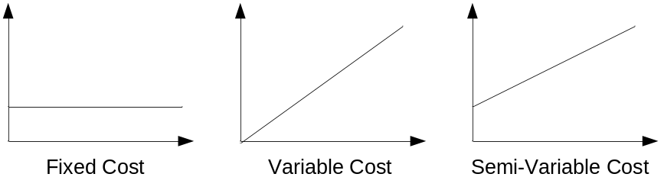

Beware of the possible calculation error that when fixed costs have been unitized, that is associated with each unit for production for a certain number of units.
Example: Fixed costs/unit=$2 (when 100 units are produced), variable cost/unit=$2, for a total unit cost of $4. When production is raised to 200 units, the fixed cost per unit does not stay the same; it is now $1/unit as it is now spread across 200 units. When looking at per unit cost, it is not always clear whether fixed costs have been unitized or not.

Costs that are seen to be incurred only because of the item is manufactured is termed direct costs. All other costs are indirect costs. Indirect costs are seen by the accountants as being costs incurred in support of the fundamental activities of manufacturing, buying, and selling; they are not attributable to a single product or range of products.

Traceable costs are those costs than can be traced into the cost item. Common costs are the indirect costs incurred by a business to support the production. Without qualification traceable and common costs are the same as direct and indirect costs. A company with just one product line will not have any common costs as all costs can be traced to that one product (line).

Product costs are costs that can be attached to the cost item without undue difficulty; period costs are those costs which, although incurred ultimately in the support of the product, are best controlled in time periods.

Controllable costs are costs that are controllable by a certain manager (supervisor, etc.) in a certain timeframe who can be held accountable for the costs being measured. Non-Controllable costs can not be controlled by that manager or can not be controlled by the manager in a certain timeframe. For example overtime can be controlled by a project manager, while business insurance cost can generally not be controlled by him. Managers should only be measured by costs that they can control.

Standard cost is the budgeted cost for one cost item which is based not on engineering studies but on recent experience. Against this norm the actual cost is measured period by period. Standard Cost would comprise variable and a share of the fixed cost.

Costs that can not be avoided in the production of a cost item (such as the raw material and the labor it takes to produce the item), that is costs that are engineered into the product are called engineering costs. All other costs, e.g. machine maintenance, R$D, etc., must not necessarily be incurred in every accounting period; these costs are called discretionary costs. Discretionary costs can be reduced rather quickly if the business faces a decline.

Break-even Analysis
Break-even analysis is also called Cost-Volume-Profit analysis.

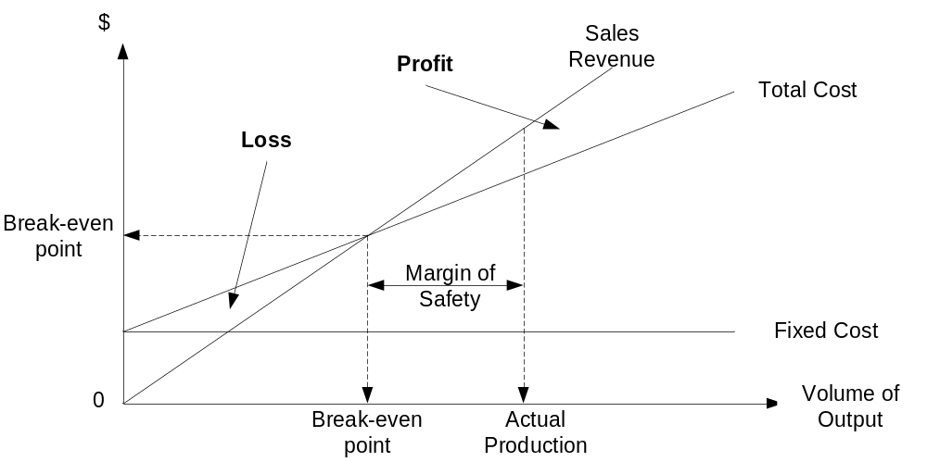

The shape and angle of the total cost curve is defined by the cost structure. Management can influence the cost structure to a certain extend.

Profit/Volume Ratio (P/V ratio) = “Profit”/Sales Price
=(Sales Price – Variable Cost)/Sales Price
In Break-even analysis the fixed costs are taken as a given and the focus the attention on the rate at which profit is earned. This “profit” is usually referred to as contribution.

Break-even analysis can also be displayed by looking only at the volume and “profit” (contribution)

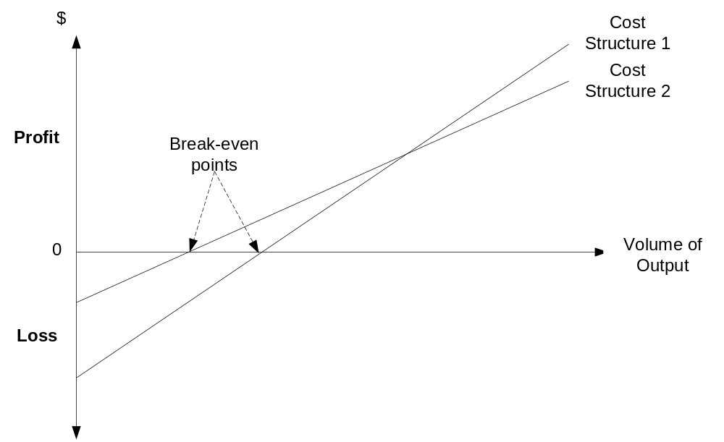

Equation Method of break-even analysis:

Sales = Fixed costs + Variable costs + Profit
Break-even sales = Fixed Costs + Variable Costs

Contribution Margin Method of break-even analysis:

Contribution Margin = Sales revenue – Variable costs
Break-even point (BEP) (in units) = Fixed costs/Contribution margin per unit

Contribution Margin Ratio Method of break-even analysis:

P/V ratio = Contribution margin per unit/Sales revenue
BEP = Fixed costs/ p/v ratio

The secret of good management is to identify the limiting factors and calculate the contribution margin per unit of limiting factor. The higher the contribution margin per limiting factor, the more the good in question contributes to the bottom line.

Assumptions underlying the cost-volume-price analysis:
- All costs can be identified as either fixed or variable
- Variable costs rise linearly, fixed costs are the same for all volumes produced
- Sales price per unit remains unchanged
- The sales mix (mix of products) will be maintained precisely as budgeted, as total volume moves up or down
- All production is sold

Module 10: Allocating Costs to Jobs and Processes

Through the analysis of the details of cost gathering and allocation that a manager is able review alternative costing systems that are more in line with his objectives. The requirements on costing systems can be summarized as follows:

- Controlling actual performance against planned performance
- Planning next year’s cost
- Tracking the consumption of resources
- Choosing among alternative courses of action

Controlling and tracking are backward looking. Planning and Choosing are forward looking.

Cost Statements (Where do costs come from?)

Materials are used from inventory. Usually a standard price for a certain time period (e.g. monthly, weekly) is set as it is often not feasible to maintain the price of every single item of raw material. Any difference in the actual purchase price and the production issuing price are accounted in the P&L account as a price variance at the end of a given period.

Labor cost is a multiple of time spent on a job and rate of pay earned by the operatives involved. The time spent during manufacturing on each item is noted either with the cost item or on a timesheet of the operative in order to allocate time to cost items. The rate per hour is not easily determinable as the productivity and the pay rates vary between operatives. Again standard pay rates per hour are used.

Overheads: Manufacturing and Share of Non-Manufacturing are both indirect costs. Overhead costs should be collected initially into cost centers, that is, pockets of activity for which individual managers can be held accountable. Each principal cost center manager might decide to split her center into sub units of responsibility and control; in such circumstances a target expenditure level will be set for each sub unit beyond which the individual manager must not go without prior approval. Incurred costs will be allocated by the cost accounting department based on invoices received, and in case of depreciation an agreement on annual write off rates and assumed second hand values.
Because it is not possible to link overhead directly a predetermined overhead rate is used.

Predetermined overhead rate = Budgeted overhead for accounting period/Budgeted for production units

When a company has more than one product the overhead cost has to be allocated to the different types of products. In order to do that accountants look for casual factors or activity bases, that is the one particular factor that prompts the incurrence of most of the headings of cost which comprise overhead. Typical activity bases are:
- Direct labor hours
- Direct labor cost
- Machine hours

Plantwide vs. Departmental Rates
Using one plantwide predetermined overhead rate for a one-product or more-than-one-product but single activity base company is often an oversimplification. Management must design a cost allocation system that reflects each product’s actual usage of overheads. Several methods can be used:
Direct Method: The overhead costs from the overhead (service) departments are emptied out into the production departments based on a suitable activity base and added to the already existing manufacturing overhead. The direct cost does not account for interdepartmental use of the service departments’ among each other.
The Step Method takes the services between the service departments into account. An order in which to close down the service departments’ costs can be done
- by selecting service departments by descending order of magnitude of overhead spend, or
- by selecting first the department that renders the highest percentage of it’s total services to other service departments

Joint Products and By-Products
The characteristic of a joint product is that it must appear during the process involved in producing the main product. If management has the option that the second product does not emerge from the production of the man product it is not a joint product. The production costs can be split between the joint and the main product in the following ways:
- Equal shares: Simplicity of operation and a desire to reflect the relative easy with which both products emerge from the production process are the driving forces.
- Physical characteristics: Certain characteristics (such as weight, volume, etc.) cause certain costs to be incurred.
- Sales value at split-off: considers the product’s ability to bear the joint costs as measured in the ability of the product to generate revenue.
- Ultimate net sales value: recognizes that the products might be processed further after the split-off in an effort to maximize profit

Why does a business need to measure and allocate the production cost in this complicated manner given that the total sales revenue and total cost across both products does not change?
- Product management might need to make decisions on marketing, design, or development of different products. Indication of initial cost provides a benchmark for internal resources already consumed by the product.
- For inventory valuation purposes the business must attribute a value to the cost of goods sold and unsold.
- For price setting under cost-plus pricing (used mostly in government contracts)

By-products are different from joint products only in terms of motive and commercial value. Joint products are planned for and the production process is set up to cater for them. A by-product is a product that emerges from a process that is set up for another product. Net revenues from by-products are deducted from the cost of production before determining the gross margin. The costs are not allocated across the different products. A by-product can change over time to a joint product and vice versa.

Process Costing and the Equivalent Unit

In order to use job costing, the cost items are physically separable to such an extend that cost can be traced to each one; the items are deemed individual jobs which incur separate costs. Process costing is used when no uniqueness is identifiable in the products produced and where the process is almost continuous.

In process oriented production, the work-in-progress at the beginning and the end of the process might be in different stages of completion at the time that the cost needs to be calculated. An equivalent unit of production is an assessment of the degree of completion of a unit in under each major component of cost over a time period over which the costing needs to be performed.

Example:
A company starts the year with 2 million liters of paint in production that are 50% complete. During the year it produces 12 million liters of paint as output. At the close of the year is has 4 million liters in production that are 25% completed.

 | Material | Labor/Conversion
Opening work-in-progress | - | 1 million
Units started and completed | 12 million | 12 million
Closing work-in-progress | 4 million | 1 million
Equivalent units of production | 14 million | 12 million

In order to determine the cost of material per unit, the total material cost has to be divided by 14 million. In order to determine the cost of labor per unit, the total labor cost has to be divided by 12 million.

The FIFO method for production costing calculates a period’s cost precisely as incurred and without averaging out the cost. The weighted average cost method can be used when cost fluctuations around a predictable level occur and management does not need to be altered of the regular fluctuation in unit cost.

Activity-Based Costing

Activity-based costing (ABC) focuses on the activities (e.g. production planning, quality inspection) that produce costs under the assumption that products then “consume” activities. How does activity-based costing cater for common cost accounting shortcomings?
- Cost and financial accounting are decoupled. By focusing on ABC the cost of a product becomes a major driving factor rather than being subservient to the inventory valuation.
- Different activities have different cost drivers (casual factors). Thereby the allocation of cost is performed using a more complex but more realistic loading of overhead costs to the products compared to just using e.g. machine hours or labor costs.
- ABC embraces all overhead costs, even the ones not associated with the production process. This is important if some products consume a proportionally larger share of the overhead costs.
- ABC reflects the complexity of production and marketing, which permits simple products that require little overhead to be loaded up only with the costs they incur.
- ABC permits a strategic insight into the business by providing accurate product costs.

ABC is most helpful in industries that produce customized products in low volumes and where product diversity, speed to market, quality and reliability are the factors that keep a company competitive.

Module 11: Cost for Decision Making

Absorption and Variable Cost Accounting
Under full or absorption cost accounting the full amount of the cost of sales (variable and fixed, direct production related and direct production overhead) are charged against the sales revenue to arrive at the gross profit. Under variable or direct cost accounting the fixed costs of production are accounted for as a lump sum.

Example: Fixed costs per unit = $50, Variable costs pre unit =$10

Absorption cost accounting
Sales (10,000 units at @ $100) $1,000,000
Less: Full cost of sales (10,000 @ $60) $600,000
Gross Profit $400,000
Less: Other Expenses $200,000
Net Profit $200,000

Direct cost accounting
Sales (10,000 units at @ $100) $1,000,000
Less: Variable cost of sales (10,000 @ $50) $500,000
Contribution Margin $500,000
Less: Other Expenses $200,000
Fixed cost of sale $100,000
Net Profit $200,000

In order to determine the standard cost per unit would be calculated as follows: Budgeted manufacturing (or non-manufacturing) overhead divided by the budgeted volume of output (units or hours).
When the actual production does not match the planned production the different systems produce diverging numbers. This can be due to
- a denominator volume variance when the actual production of units is lower (higher) than planned. In this case the fixed costs are not fully recovered from the (planned) fixed costs per unit and have to be added at the end of the accounting period as a write-off.
- the fact that under absorption costing the units in the inventory are valued at a cost that does include the full cost of sales and thus an impact to the profit differs when inventory is reduced/increased during the accounting period.

Which method of costing should be selected by a business? The method that flags up the clearer set of signals to management should be selected. Two main factors need to be considered:
- The risk in selecting direct costing is that Sales might only see the variable cost and be tempted to reduce the price to get additional revenue. This in the long term will lead to the problem that fixed costs are not consistently recovered. Absorption costing avoids this problem, but might prevent price reductions in a situation of competitive stress where recovering variable costs is better than no cost recovery at all.
- Under variable costing profit is a function of sales, that is when sales rise, so do profits. But with absorption costing profit is not only influenced by sales but also by production levels. By stepping up production beyond sales, management can increase profit because more fixed production expenses are ‘parked’ in inventory. This action must inevitable be reversed because of cash flow problems. The ‘parked’ fixed costs when the goods come out of the inventory hit the P&L statement.
Managerial requirements might differ from the tax authority’s requirements (which in most cases require absorption costing). Flexible accounting IT systems allow for fulfillment of requirements by special user groups such as tax authorities.

Cost Information for Management Decision
Routine decisions are decisions that take in the normal course of events (dealing with a difficult customer, disruption to production due to machine failure, etc). These decisions usually require mostly the manager’s people and discussion skills. If cost information is required at all for these types of decisions the information will usually be extracted from the routine cost systems described earlier.
Non-routine decisions require more logical and thorough analysis. Cost data tends to be necessary to a large degree in making the decision. Examples could be whether to shut down a product or department, invest in a new R&D project, or continue with a current or a different supplier.
The analytical framework for making non-routine decisions can be defined as follows:
- Define the problem and list all feasible alternatives
- Cost the alternatives (cost outlays and cost savings). The relevant costs should be developed, that is the costs that differ for the alternatives under review.
- Assess the qualitative factors
- Make the decision

Relevant cost is a cost that changes as a result of the decision being contemplated. The following points need to be kept in mind when deciding on the relevant costs:
- When using full costing in the preparation of costing for management decisions care has to be taken to properly adjust for the fixed costs under full cost accounting included through full costing in the per-unit cost. If fixed costs are allocated to units of production they appear as if they were variable costs, meaning they seem to rise when the number of units produced increases.
- When management makes the decision for one path to go forward, the opportunity cost, that is the highest cost of all other opportunities foregone, needs to be taken into consideration.
- It is also important that a company wide and not only departmental point of view is taken.
- Costs which have been incurred are called sunk costs and should be ignored when looking for relevant costs.

The following costs are relevant costs:
  - Future costs
  - Cash costs (the manager needs to be concerned with the real money implications of a decision and not the accounting implications such ad depreciation or asset write-off)
  - Avoidable cost (future costs that are not avoidable do not add value to the decision making process)
  - Those costs that differ among the alternatives

The following three scenarios are common non-routine management decisions:
- Closing down a unit: Management needs to decide whether to close down a unit, production line, product, etc. temporarily, permanently, or not at all when it is encountering difficulties. The problem can be analyzed by looking at the options of how long the unit should be kept going.
- The special sales order: Management needs to decide if it wants to offer better conditions to a large potential customer than it usually does.
- Should we process further: Management needs to decide whether it is worth to process a by-product of a process further.

Module 12: Budgeting

Budgeting enables companies to harness, direct, and control employees’ efforts and motivation. Budgeting has the following attributes:
- Coordination: Budgeting coordinates activities within the same organization.
- Planning: A detailed plan sets out the targets for the entire organization to aim for.
- Motivation: Once the business’s budget is broken down in to its constituent parts the departments and individuals have a clear picture of the road ahead, the targets to aim for.
- Control: A budget provides a control benchmark against which to measure actual performance.

A budget is a plan of action, usually expressed in numbers and amounts, that sets targets for individuals and for the business over a defined future timeframe. Planning of a businesses future, that is strategic planning, must precede the budget exercise. Strategic planning is the managerial exercise that attempts to ensure that a business accomplishes a sufficient process of innovation and change by allocating scarce resources (cash, managerial skill, technological know-how) by adapting to environmental opportunities and threats and by coordinating activities so as to reflect the business strength and weaknesses.

Why budgeting gets a bad name?
- The time taken in an iterative budgeting process that is executed well in advance of the budget period (year) makes it hard for managers to plan the next year when they might only be half way through the current year. The budget process should start as late as possible in the current period (year) consistent with getting agreement by the start of the next year (period).
- A less-than-professional approach and lack of commitment to their own responsibilities of keeping within a budget by top management will ultimately lead to the breakdown of the budget process where managers do whatever they please in disregard of the previously agreed upon targets and limits.
- Managers often regard budgets as a form of punishment by top management. Budgets are only seen as control mechanisms in order to screw activities and the use of resources down to the absolute minimum. Proper planning requires consultation and co-ordination with all levels and not autocratic dictates from higher up. This way management will receive buy in and commitment as well as feedback on the budget and the plan.
- It is unfair and un-motivating to lower level budget holders to assess their performance on unmanageable overheads allocated to their budgets (such as R&D, Marketing, etc.) that are outside of their control. A budget holder should have responsibility only over controllable costs and revenues.
- Managers often complain that if their budgets are not updated throughout the year if circumstances change significantly the resultant comparison with actual performance is meaningless. This problem can be resolved by either:
  - Sticking to the original budget but stripping out the variance of the external event before highlighting those variances that can be viewed as that managers responsibility.
  - Implementing a rolling 12 month budget where as the current month expires another month is added at the end. This way the budget is always a 12 month view of the future and can be amended as soon as the external event becomes known.
Both methods maintain the integrity of the budget process by signaling to managers that their investment of effort in budget preparation will be rewarded by reporting visibility.
- Budgeting is said to reward inefficiency as costs and revenues are often budgeted to increase at a certain fixed percentage. Driving out inefficiencies from budgets is a difficult task, especially in areas with blurry benchmarks, such as R&D, marketing, and administration. Management should encourage competition for surplus resources within the organization rather than adopt a blanket percentage uplift method. At the same time it should not recoil from taking allocation decisions even if these are based on intuition and ‘gut-feel’ where competitive claims for resources are broadly similar in financial terms.

Discretionary costs are difficult to budget for and manage because
- the output is often difficult to measure,
- budget holders might not be sure of the companies objectives and therefore unsure about where their efforts should be focused, and
- it might not be easy to control it on an annual basis (e.g. in R&D where a year is a very short timeframe)

On technique to ensure that discretionary cost budgets provide sufficient visibility is called zero-base-budgeting. In zero-base-budgeting (ZBB) management invites certain activities to bid for their resources as if they were starting from scratch (or from a zero base) instead of adopting the normal incremental approach to annual budgeting. This tool can only be adopted in areas of discretionary expenditure with management making the decision on the appropriate level of spending. For engineering costs the sole criterion of level of spend is the production output required.

Zero-base-budgeting involves dividing activities (such as R&D) in to packages of work that can be separated from each other. The packages are costed and ranked from essential to beneficial. Top management then assigns priorities to all packages and makes decisions on tradeoffs between different packages independent of the budget holders that have a vested interest (e.g. job preservation) in the budget for their corporate function. Corporate functions also have to identify minimum level of expenditure under which they are not able to operate. New requests for increased spending must be prioritized against existing commitments.

Zero-base-budgeting has two significant drawbacks:
- Dividing activities in to packages is often problematic and requires a lot of effort (and cost).
- The definition of the packages is left to the management of the function under review. This might leave questions open on the potential vested interest in the definition of the packages. Top management might need external expert opinion to review the packages.

Module 13: Standard Costing
Standard costs are budgeted costs for individual cost items. Budgets are made up of many standard costs. Standard costs are compared with actual costs and explanations are sought for any differences between the two.
- Material usage standards: An engineering study will help to determine the following two standards:
- The ideal or engineering standards are the standards achievable (e.g. amount of material needed) if every aspect of production works to maximum efficiency.
- The normal or operating standards are those that can be expected to be achieved by a productive operation operating carefully and efficiently, but which also reflects the normal perils.
- Material price standards: The standard selected for the year will based on expected purchase patterns, estimate of price movements, discounts negotiated, quality required. If significant fluctuations in the material inputs are to be expected (e.g. cocoa beans), the budget period might be shortened.
- Labor usage and price standards: The engineering study will provide the time required to produce product of a certain quality. The normal standard would take into consideration normal times for breaks, etc. The study would also describe the level of competency of the operator that would be required. The standard price is calculated by having regard to the current rate and any anticipated increases.
- Overhead standards tend to be determined by reference to one of the four standards already described (e.g. overhead per material usage, or overhead per labor hour). The standards for variable and fixed overheads depend on:
- budgeted cost of each overhead
- allocation key to be used to allocate overhead to product
- the volume expected by each allocation to be used

A flexed budget is a budget that has been adjusted to account for the variances in cost due to a difference between budgeted and actual production numbers.

Material cost variances can be caused by two reasons:
- The actual production used more (or less) material than planned
- The price to purchase the material was more (or less) than planned.
Material Efficiency Variance = [Standard Quantity – Actual Quantity] * Standard price per unit = [SQ-AQ]*SP
Material Price Variance = [Standard Price per unit – Actual Price per unit] * Actual Quantity used = [SP-AP]*AQ

Labor cost variances can be caused by two reasons:
- The actual production used more (or less) time than planned
- The labor rates paid were more (or less) than planned.
Labor Efficiency Variance = [Standard Time allowed – Actual Time taken] * Standard rate per hour = [ST-AT]*SR
Labor Rate Variance = [Standard Rate per hour – Actual Rate per hour] * Actual Time taken = [SR-AR]*AT

An adverse variance is on e where actual cost is above standard cost, a favorable variance is one where the cost is less than the standard cost.

Why is the standard rate/price used? The variances defined above provide insight into the financial impact of the deviation from the budgeted and planned costs. By holding all rates/prices as standard the efficiency of production can be examined. Were one to use the actual price/rate, two variables would change at the same time (quantity and price) and thus the number would be meaningless. In the price/rate variance the actual quantity/time is used because if the budgeted quantity/time would be used the variance would have no resemblance to the reality and e.g. a purchasing manager might be held accountable for a material price variance that is actually smaller (if less was purchased) than the material price variance when using the actual quantity purchased.

Variable Overhead Variance = Standard cost of variable overheads – Actual costs of variable overheads
Efficiency Variance = Standard cost of flexible budget time allowance for units produced – standard cost of actual time taken for units produced
Spending Variance = Standard cost of actual time taken for units produced – actual costs incurred

Fixed Overhead Variance = Budgeted Amount – Actual Amount
Fixed Overhead Denominator Variance = Budgeted Amount – Amounts applied to units produced using standard per unit fixed overhead cost

Exception reporting or management by exception is a form of reporting where managers only receive information on items that appear to be out of control.

The sales quantity variance describes the difference between budgeted and actual numbers of units sold.

Sales Quantity Variance = [Actual Sales in units – Budgeted Sales in units]*Budgeted weighted average contribution margin per unit

The sales mix variance values the increase or drop in units sold per product line by the difference between actual contribution margin per product line and the budgeted weighted average contribution line.

Sales Mix Variance = [Actual Sales in units – Budgeted Sales in units]*[Budgeted contribution margin per unit – weighted average budgeted contribution margin per unit]

Module 14: Accounting for Divisions

Divisions
Advantages of divisions:
- Specialization: specialist and potentially local management for different parts of the company
- Size: detailed knowledge can be brought to bear (e.g. by product, or by geography)
- Motivation: Employees working away from the center of an organization can be de-motivated and demoralized by having decisions made about their activities by a remote management in headquarters. Better to give control and a feeling of ownership to to the individual units and run them like separate companies
- Sharper decisions: local solutions to problems can be identified and solved much quicker
- Career mobility: Individuals respond to challenges and rewards for successes. The headquarter team can be drawn from the best available managerial talent in the divisions that serve as “testing” ground

Disadvantages of divisions:
- Lack of control: Once a division has been established and a management team has been given the task to “run their own ship”, the headquarter has lost a certain degree of control.
- Cost: Divisions need their own overhead staff (e.g. HR) and is therefore seen to cost more money. Companies can either see this as a necessary cost to reap the benefits of divisionalization or can reduce headquarter overhead.
- Internal rivalries: If divisions are set up with a performance measurement system that will highlight superior performance, a spirit of competition and internal rivalry may be created which is dysfunctional to the overall objectives of the company.

Types of divisions:
- Cost centers: Divisions are only held responsible for the incurrence of costs and are not responsible for the generation of associated revenue.
- Revenue centers: divisions are given the task of generating funds without any reference to the underlying costs.
- Profit centers: cost and revenues are matched and divisional performance in assessed on bottom-line profit.
- Investment centers: the divisions’ net assets are taken in to consideration when evaluating profit performance. This allows the evaluation of the efficiency of the use of the assets at the disposal of the division.

In determining the asset base to be used for the performance evaluation the following asset base valuations can be used:
- Net book value: net book value is the difference between the original purchase price and the accumulated depreciation. All other things being equal the net book value will decline over time and thus the return in investment will increase. Such a trend might inhibit divisional managers from replacing ageing equipment, although that might be in the long term interest of the company (and the division).
- Current replacement costs: the most appropriate replacement cost for specific assets is determined and then used as the asset base to evaluate the performance of the return on investment of the division. The subjectivity in determining the replacement costs and the time taken up by such an exercise prevent most companies to employ this valuation technique and tend to use the net book value despite its shortcomings.

Using ROI as an indicator might lead to dysfunctional behavior in the following way. Assuming a company’s cost of capital; is 10% but a divisions ROI is 20%, the division might not undertake a project that would bring in 17% ROI because it might ‘water down’ the ROI of the division although it still would be in the best interest for the company.

To overcome the above mentioned problems companies can use residual income (RI) measures. Here each division is charged interest on its invested capital, such interest being set at the rate of the company’s cost of capital, and management’s goal should be to accept investment proposals which exceed the imputed interest charge. Residual income is expressed in absolute money terms, ROI is expressed in percentages.
Instead of using the companies cost of capital, management might assess the commercial risk associated with each division, thereby imputing different rates of interest across divisions.
The selection of the imputed interest does matter to the calculation of RI due to the effect that gearing has. Low interest rates favor divisions with high investment in net assets, when interest rates are higher, the high investments made in assets make themselves felt in the high imputed interest rate charge levied on the division.

Transfer Pricing
If managers are allowed to set their own prices, a division might decide to go outside of the group to purchase the group or service if it gets a lower price there. Although in this case a decision by both divisions to not to deal with each other might suit them, the well being of the company as a whole is harmed.

Market pricing is by far the best method for transferring goods and services between divisions because it can be objectively tested by both parties. Care has to be taken to ensure that the market price reflects similar products of similar quality and similar conditions, such as warranties, service, and transportation.
When market based pricing is not readily determinable, cost based pricing can be used. Full cost pricing includes the variable cost as well as a proportion of the fixed costs. When using full costing it might be appropriate to let the buying division’s accountant audit the selling division’s cost to make sure that they have no slack build in to their cost structure. For the buying division the price paid to the selling division becomes a variable cost to which it would add it’s own variable cost. If the buying division would then price it’s products with an eye on the contribution margin, the ‘variable’ cost would contain a proportion of the fixed cost of the selling division. Under market pressures when the buying division might have to use pricing based on variable cost only, it would have a higher variable cost than the company variable cost due to the proportion of fixed cost contained in the variable cost. In this case full cost pricing might lead to loss of sales.
From an overall company perspective variable cost pricing overcomes the shortcomings described above. However in that case there is no incentive for the selling division as it is not able to recover fixed costs and the full benefit of the sale goes to the buying division.
Negotiated cost pricing is used when market based pricing and cost based pricing has not worked and headquarter management has instructed the two divisions to come up with a solution. Top management might want to participate in the negotiation process to make sure that the interests of the whole company are considered. In special situation headquarter might allow a dual pricing scheme where the buying division pays a lower price than the paying division receives, with the difference absorbed by an headquarter contingency account. However, such a scheme would result in loss of confidence in the system and motivation between the management of the two divisions.

When considering transfer pricing between international divisions, the following additional items have to be considered:
- Taxation: if the transfer pricing can be geared so that the ultimate profit emerges in a tax regime with low corporate profit taxes, the overall tax bill of the company is reduced.
- Repatriation of profits: if a country would not allow the repatriation of profits by a way of cash transfers of dividends, transfer prices could be adjusted so that the division located in the restricted country is asked to pay a high transfer price.

Determining a transfer price that
- motivates divisional managers,
- permits an evaluation of their division, and
- leaves them to ‘run their show’
is extremely difficult.

Module 15: Investment Decisions
Investment Process:
- Search: identifying or finding the suitable investment opportunities. Accounting on itself usually does not have a lot to offer in finding investment opportunities. It is the responsibility of every manager to search worthwhile investment opportunities.
- Control: once an investment has been taken the financial control of it will follow the normal budgetary control procedures. There will be specific project budgets for major investment projects. There will generally also be a capital budget that shows the aggregate total of capital being invested in the given period.
- Evaluation: between search and control of an investment lies evaluation to ascertain if it is economically worth wile.

Present value: money payable or receivable at different points in time has different value. The difference does not derive from inflation or risk. Rather from the possibility that e.g. a dollar available right now, compared to in a year, would be available for consumption immediately and thus fulfill a need right now or could be invested right now, earning interest for the next year. The ability or the need to earn/pay interest is fundamental to the concept of present value, as the interest rate is used to give an equivalent value to money paid at different points in time.

Net Present Value
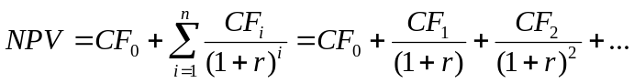
NPV: Present Value of a future cash flow
CF: Future Cash Flow in time period i (cash outflows are negative)
CF₀: Initial Cash Flow
r: cost of finance, or cost of capital
n: number of time periods

When should an investment opportunity be undertaken?
- If the NPV>0 the rate of return of the investment opportunity is higher than the cost of capital and should therefore be undertaken.
- If the NPV<0 the rate of return is lower than the cost of capital and should not be undertaken.

In order to compare return of investment for different projects one should consider the NPV/Initial Investment in order to compare small and large projects equally.

Discounted Cash Flow Rate of Return (DCF) or Internal Rate of Return (IRR) calculates the rate or return at which all (fixed) future cash flows would deliver a NPV of 0. The resulting number can then be compared with the cost of capital. If the IRR is over the cost of capital, the project should be undertaken, if it is below the cost of capital it should not be undertaken.

If management has to make a decision whether to undertake an investment project or not, both, NPV or IRR will deliver the same recommendation following the financial analysis. However, when comparing two alternative investment opportunities, the two numbers might suggest different approaches, as the NPV is an absolute number (e.g. NPV = $245) while the IRR is relative (e.g. IRR = 12.4%). Further analysis into the differences between the two projects’ cash flows, opportunity cost, and potentially other investment opportunities have to be considered in order to make a decision.

Investment appraisal in non-revenue and not-for-profit situations still can user the concept of NPV to support the reaching of a decision. In this case the NPV is used to compare different options only regarding cost, no cash inflows are expected.

Methods to deal with risk in investment decisions:
- Do not deal with risks at all in a quantitative way. The investment estimates are simply developed using the ‘most realistic estimate under the circumstances’ and the evaluation is performed using the discounted cash flow approach.
- Apply a ‘high hurdle’ test, e.g. projects that are regarded to be a high risk project have to pass a higher targeted rate of return for approval. The problem with this approach is that the risk of individual components of the project is not broken out. Payback period is another example of a high-hurdle test.

The margin of safety is the amount by which a project can deviate from the targeted estimates before a profit is turned into a loss.

Payback period is the time it takes to recover the original investment. The payback period has to be calculated using the properly discounted cash-flows in order to adjust for the time value of money. The weaknesses of using payback period for investment decisions is
- that it is implied in the assessment of risk that there is a standard payback period against which the forecast is compared. Although a company might set it (e.g. 5.0 years for low risk projects, 2.5 years for high risk projects), there is no external reference for guidance, such as the financial marketplace for the IRR targets. Another weakness is that
- payback looks at the break-even position and ignores the profit that will be generated after break-even.

In sensitivity analysis in the simplest form changes one key variable (e.g. quantity, or price) and assesses the impact on the final result. It is not an evaluation technique but aids management in the exercise of judgment.

When performing risk analysis, the probabilities of a range for a variable (e.g. selling price) are estimated. This estimate is a subjective probability, as it is usually not based on repeatable events that have happened in the past (which would give an objective probability).

The key investment factors highlighted by appraisal techniques are:
- Capital investment: Cash flows required will be the fixed and working capital required, the amounts, their timing. A frequent reason for not realizing the estimated profitability is that the project took longer than estimated and therefore the future cash inflow was delayed, reducing profitability.
- Operating cash flow: operating cash flows are the cash flows that occur in the operating period. The will arise out of inflows from sales and outflows from operating expenses. When making an investment decision many businesses need to see the impact that the investment will have on the financial statements. In some cases taxation/subsidies need to be considered just as other cash items when the IRR after corporate taxation is assessed.
- Investment life: The duration of the useful life of an asset can be determined by
  - Physical: wear and tear leading to breakdown make the asset physically unusable or serviceable
  - Technical: the asset becomes obsolete due to technical advances that have brought e.g. a superior and more economical production machine to the market.
  - Market: The product or service that the asset provides might no longer be in demand.
The investment life for appraisal purposes will be the estimate of which of the three factors will occur first. The investment life is then used to calculate the depreciation.
- Cost of capital: The IRR of the project will have to exceed (or match) the company’s cost of capital in order for the company to approve the investment project. Alternatively the NPV of the investment has to be positive using the company’s set cost of capital in order for the project to make economic sense. Companies may set different rates for the cost of capital for different projects.

Projected cost of capital for the sources of long term financing of a company:
- Fixed interest loans: the cost of these to the business will be the rate of interest it has to pay on the loans plus an allowance for the cost of raising and servicing the loan less taxation (if applicable)
- Fixed interest (divided) shares: the cost will be the net interest (dividend) payment plus an allowance for the cost of raising them. In the UK the interest (dividend) is not allowable for taxation purposes so the cost can not be reduced by the tax rate.
- Residual equity shares: no predetermined rate of interest attached. However when new share capital is issues the current earnings per share (EPS) should at least be maintained (taking into account the share issue expenses).
- Retained earnings (profit): While a dividend does not have to be paid on the retained earnings, the relative value of the shareholders’ interest in the business has to be maintained; the funds for the investment should earn at least the same as the existing investment.

When the projected average cost of capital for each of the sources of finance has been calculated, the weighted average cost of capital can be calculated.

When management adopts the view, that an investment has to earn at least the rate of interest that it would be able to achieve if the funds were invested externally, it is taking the opportunity cost into consideration. The cost of capital in investment appraisal then becomes the targeted rate of return. Using a targeted rate of return also allows for the inclusion of general and specific allowances for risk and uncertainty. A general uncertainty is that not all projects will reach the targeted rate of return and therefore a generally higher target is set so that the actual rate achieved in (hopefully) in line with the original target. Specific uncertainties can be incorporated e.g. through the definition of risk categories and association of higher IRR targets with riskier projects.

Inflation is important when evaluating cash flows over longer periods of time. It is a separate from the ‘time value of money’ concept and has to be accounted for separately. Care should also be taken in looking at the different impact that inflation has on different variables (e.g. wages vs. computer equipment).

Module 16: New Developments in Management Accounting
Perceived shortcomings of current management accounting:
- Management accounting procedures are being driven by the requirements of financial accounting with the focus on profit measurement and therefore inventory valuation. When costing systems develop from inventory valuation systems the goal of costing products becomes obscure.
- Although direct labor as a percentage of the total product cost is shrinking, yet despite that the direct labor cost is still often used to allocate overhead, leading in some cases to triple digit percentages
- Modern production technology and systems have rendered obsolete the traditional assumptions about which costs are variable and which ones are fixed.
- In order to allow a company to differentiate itself from the competition, more and more additional overhead is required. Still the business might regard overhead as a burden to be squeezed out from the cost profile.
- Product lifecycles are shorter and product ranges much wider resulting in more and more complex companies. This puts a strain on the traditional management accounting systems and procedures.
- Increased global competition and resulting price pressure demands more and more accurate product costing within a management accounting system.

Target Costing
Target costing has been developed to help companies manage their costs in circumstances where the selling price is known (e.g. through a well understood market). Usually industries with fast moving technological change use target costing. The target price is set on the basis of the customers’ perceived value for the product or service and an informed assessment on how much the competition will charge when they catch up. Once the target price is set the target cost can be determined by deducting the target profit from the target price. The target cost will determine the point beyond which the company would find it uneconomically to produce and sell the product.

Target cost differ from standard cost is as much as the standard cost is only set once the production and the design is stable and unlikely to change in the planning period.

Target costs are usually lower than the existing product costs. Thus often value engineering has to be applied, that is reexamining every step in the development, production, sales, etc. process, in order to find ways to reduce cost to arrive at the target cost. Target costing involves reevaluating direct and indirect costs.

Life Cycle Costing
The annual periods that financial accounting is forced to use for regulatory reasons is unnatural because production and sales does not simply stop at the end of the year but is a continuous activity. The annual budget cycle is another reason that management tends to think largely in annual cycles.

Investment appraisals and capital budgeting are two items that breach the annual accounting cycle. Life cycle costing also breaks the annual accounting cycle. Life cycle costing focuses on the time that starts with the initial conception of the product or service (e.g. in R&D or by the service provider) and ends when the product or service is withdrawn and all associated customer service is also ended. Lifecycle costing gathers all revenue and costs associated with a product or service over its whole lifecycle time span so that it’s ultimate profitability can be measured and management decision taken thereon.

Lifecycle costing is often used alongside target costing, particularly with products with a long lifecycle. Tracking the effects of costs through the whole lifecycle will allow for better and more accurate cost measurement and the setting of tight target costs for any additional expenditures (e.g. re-designs) during the product lifecycle.

Throughput Accounting
When taking the ‘throughput’, that is the rate at which money is earned, certain situations might tend to use different management accounting principles than traditionally used.
- Depreciation and other, in the short term fixed, costs, such as anything that does not move with production (e.g. labor) should be grouped together as one cost into total factory cost. Only material costs should be excluded as they can be influenced in the (very) short term.
- Value is created in a business only when it sells a product. As such inventory does not create value but only incurs costs and is something that should be driven down and out of the business. This way management can concentrate on maximizing throughput from the suppliers through manufacturing and to the customer.
- Product profitability can be considered the rate at which the product earns money, not the method by which they share costs. Thus management will be able to concentrate attention on reducing bottlenecks in the production of different products or by moving resources from a product that is inhibited by a bottleneck to one that is not.
Throughput accounting stresses that fact that products do not earn money, but businesses earn money by selling products.

Return per factory hour = [Sales price – Material cost] / [Time spent at the bottleneck per product]
Cost per factory hour = Total factory cost / Total time available at bottleneck

Throughput accounting ratio = Return per factory hour / Cost per factory hour

If the throughput accounting ratio for a product is less than 1 the business is spending more money on the production of the product than it is able to receive money through sales. The throughput ratio allows management to focus on the current production constraints and distribute shared scarce resources between products to maximize throughput.

Costing for Competitive Advantage
Accounting is increasingly involved in strategic decisions. Strategy is defined as a course of action, including the specification of the resources required, to achieve a specific objective. Strategic management accounting is the provision and analysis of management accounting data relating to a business strategy; particularly the relative levels and trends in real costs and prices, volumes, market share, cash flow, and the demands on a company’s total resources.

Thanks and Revision History
The material in this document is obviously reproduced from the Accounting course text of the Edinburgh Business School. It was intended to aid me in understanding the course content, prepare for the exam, and serve as future reference. I have included in various places material from past exam questions as well as comments from fellow students that answered my questions on the “Watercooler” (http://forums.delphiforums.com/hwmba/start). Many thanks to those who make the watercooler an invaluable study help. If you find any errors, omissions or have any other suggestions for improvement, please don’t hesitate to contact me at delingat@yahoo.com. If you just want to know who I am feel free to check out http://www.geocities.com/delingat.

Revision History
Version 1.0 on December 16, 2002

